User Interfaces – Case Study

Parker Hegstrom

Robbie Daitzman

Karol Chołody

Tomas Garyga

1 Main Objectives of the User Interface

The overall objective of this case study is to design and develop a user interface (a website) that will enable a user to buy tickets to the cinema. Using the scenario that was given there were several tasks that had to be accomplished. The following is a breakdown of the tasks necessary in order to fulfill the scenario.

The functionality of being able to purchase tickets online was the end-goal of our interface. In the process of buying the tickets there were several options that had to be selected by the user (movie, cinema, and session of the movie). Once these options are selected the user can then select a seat for that film. After those steps, the user fills in a form for their own personal details, and the buying and delivering of the tickets. An option is also given so that the user can sign up for the website and in future visits skip entering their personal details again.

In order to get to the steps of purchasing tickets, a prior objective is to be able to select a film to watch and at a particular cinema. To achieve this, several paths are needed. The user will be able to look up movies by what is playing at a local theater, see what theaters are playing a specific movie, or search by a particular genre or director. A map of the location of the cinemas will also be provided.

Another objective for this interface is to provide our users with all the information necessary in order to make their choice. A key functionality we want to provide is being able to read comments and reviews of movies, and also for the user to be able to post their own comments. Info on each movie will also be provided (cinemas, director, cast, plot, photos of the movie, and a trailer). Info on each cinema will be provided, including where it is and the easiest way to get there.

All of these objectives will be accomplished by putting into practice all lessons learned throughout this course. Web design patterns, technologies for developing user interfaces (HTML, CSS, JavaScript, and jQuery), and heuristic evaluations will be used to create the best product possible.

The carrying out of this objective will first begin by creating a profile of our target audience, so that we can understand whom we will be designing this for. Then, we will examine similar existing web user interfaces in order to see some of the good and bad design practices that we either want to follow or avoid for our own interface. After the previous two steps, low-level prototypes (paper and pencil designs) will be created in order to understand how we want to design our interface. Web pattern designs will be implemented and the interface will be able to provide the necessary functions to our users. Finally, the interface itself will be developed using the technologies available to us.

2 Profile of the Target Audience

This website is created for the person who is between 20 and 40 years old, who is currently living in Madrid, Spain, and speaks English. He works in full-time job and is a very active person without a lot of free time. He likes to spend time in cinema. He prefers to go to the cinema, rather than watch a movie on TV. This person like to watch the most recent and more widely known movies, but also he likes, time to time, to watch classic movies in alternative cinemas. It means that the target has wide range of interests.

He is relatively young. He has abilities to use a computer with access to the Internet. He earns enough money to go to the cinema often.

This person likes to read comments about movies. He often relies on the opinion of others. It allows him to decide which movie he wants to see. Also, he likes to share his own opinion with others, but only after watching the movie, never before. He isn't an Internet Troll.

Apart from his predilection for know opinion of others, he likes to search movies according to their genre and directors. Probably he is fan of some directors or he has the favorite movie genres.

For this person, an important factor is localization of cinema. He prefers places near his house. He needs visualization of cinemas localizations (e.g. on the map). The price isn't the most important factor for this person. He is busy during the day, so probably he works and earns enough money to go to any cinema.

The target likes to go to cinema often, so he want to find a website which he can use more than once. He can appreciate if he can sign up to save his personal data to future shopping of tickets.

3 Good and Bad Design Practices of Similar Interfaces

3.1 Fandango

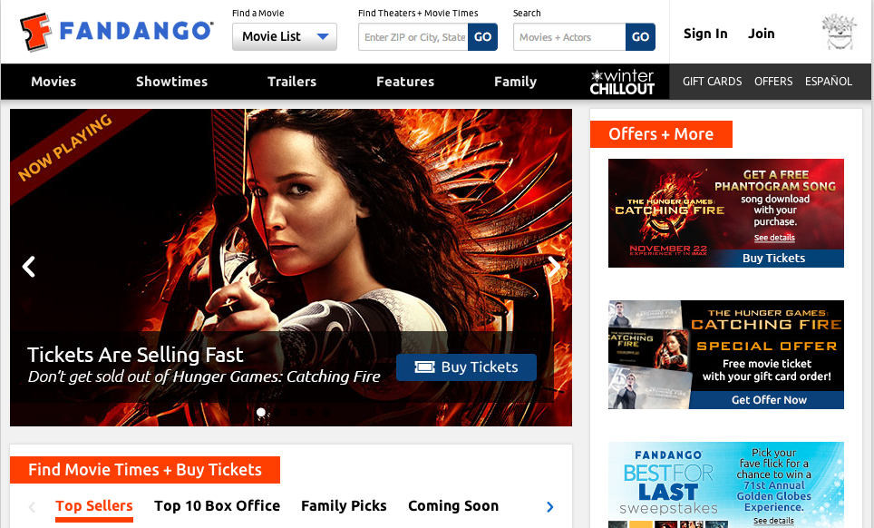

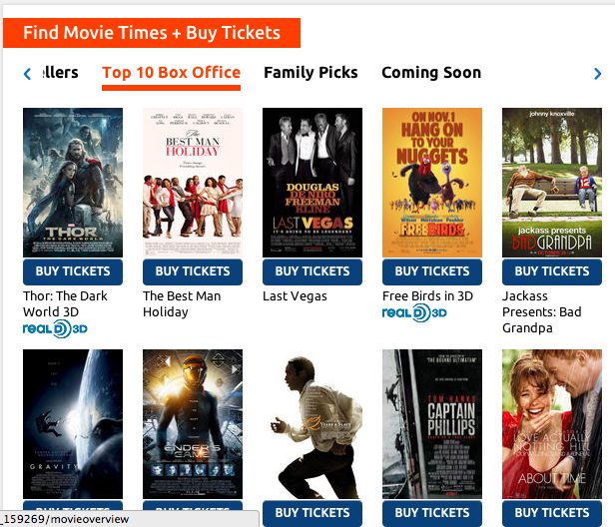

Fandango is an American website dedicated to providing movie fans with a one-stop location to search, review, and purchase movie tickets. One popular aspect of this site is that it allows the user to purchase tickets for almost any movie theater in the country, just by entering in one’s zip code or by using the site’s location services.

As one can see from viewing the homepage of the website in the previous figure, the homepage seems a bit cluttered and perhaps a little confusing as to where one should go to purchase tickets that pertain to his theater. How do you get to a page that displays movie theaters near you? I would like to see the zip code movie finder tool as the centerpiece of this page—not as a small text box at the top of the screen.

Apart from that one negative aspect of the homepage, Fandango does a great job providing a welcoming interface. The site provides quick one-click links to the most popular movies or the most recent movies to have been released. The user can then easily click the “buy tickets” tab under the movie and follow the on screen instructions.

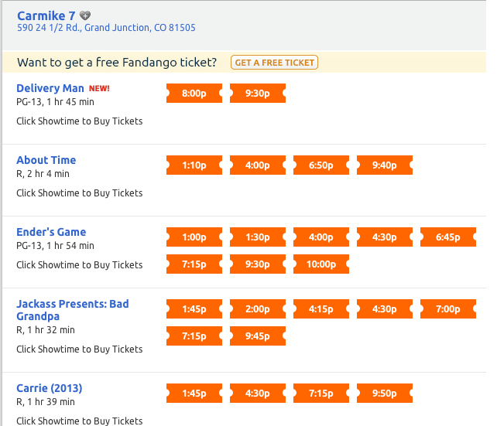

After entering in one’s zip code, Fandango provides an easy to read page that displays all of the surrounding theaters as well as the movies available at those theaters. It is easy to determine which labels correspond to the movie titles and which labels correspond to other features of the movie such as the actual show times or rating.

By reading the simple instructions underneath the movie title, any user will know that, to “Buy Tickets,” all he has to do is click on one of the available show times. Although not shown in this figure, Fandango also removes the possibility of a user buying a ticket for a sold out show time by simply crossing out that specific show time, saving the user from completing the somewhat time consuming process of completing the transaction only to find out that the ticket was not even available in the first place.

Fandango also caters to the undecided user, providing an information page for each of the movies listed. If, for example, I wanted to see more information about “Ender’s Game,” I would be brought to the following screen.

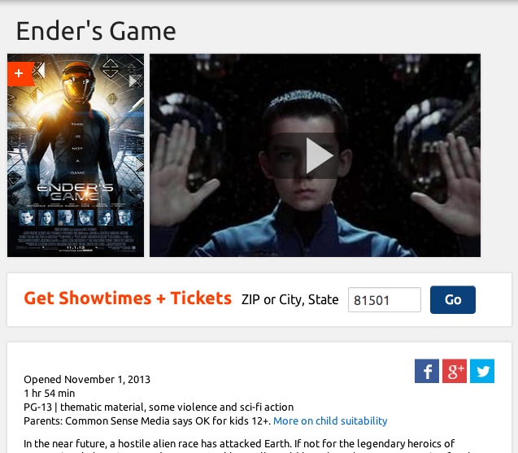

Here one is able to get a synopsis of the film as well as various ratings and the published trailer. Fandango also considers the idea that a user might find himself on this page without having determined his theater. They place an easy to read and see text box (due to its font weight, color, and size) instructing the user how to display available show times and tickets.

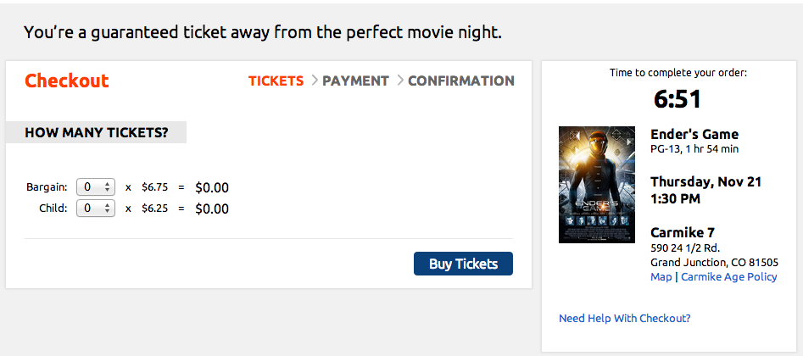

Once the user chooses a show time, he is brought to the page show in the figure above. Fandango allows the user to select the quantity and type of ticket on this page. Fandango also provides price transparency, as the user will have the total amount visible at all times. The user is also kept aware which step of the process they are currently completing (tickets > payment > confirmation).

**Fandango Conclusion**

Good Practices

* Provides many pathways to purchasing the desired movie
* Consistent and clean use of fonts and colors
* From any page that pertains to a movie, the user is always able to commence a purchase of tickets for that movie
* Once the payment process has started, the user is informed of the system status
* Errors are either prevented (in the case of sold out theater times) or dealt with in a polite and effective manner

Bad Practices

* Home page is a little overwhelming
* The option to view near by theaters and their respective movies is not easily accessible

# 3.2 [www.cinema-city.pl](http://www.cinema-city.pl)

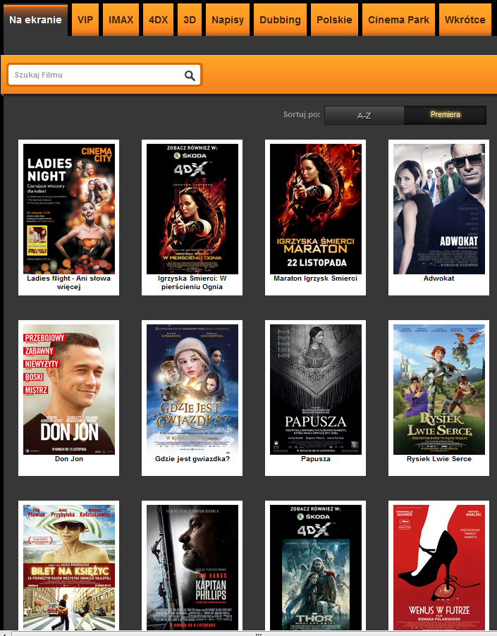

Figure 1

This website is an example of Polish cinema website where user can check what is played and also can book or buy a tickets to the cinema.

First of all, there can be recognized some good features. Every movie is shown as picture of the movie poster with label below. This type of exposition is clear and easy to understand. A second good aspect is fact that above the tabs are available. Using these tabs, users can choose if they want to see all movies or only some types of movies (e.g. only 3D, only Polish movies, movies with dubbing, etc.).

On this website users also can search movies using search tool. A good thing connected with this search tool is fact that it gives some tips when user start write (figure 2). User can choose which order he prefers: alphabetic or newest as the first.

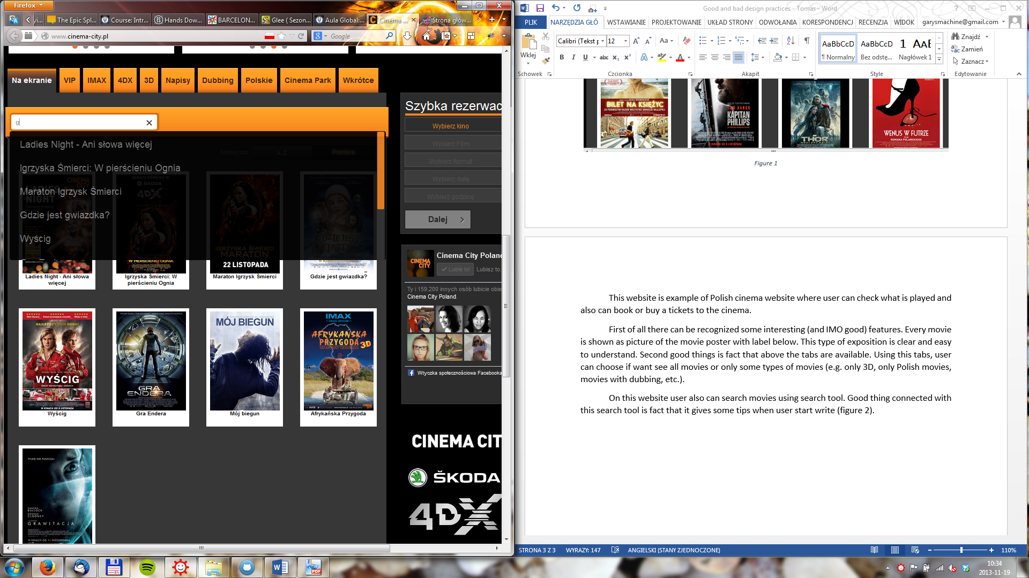

Figure 2

When a user chooses a movie, the additional screen is shown (figure 3). On this site the basic information about movie are available, like title, type, director etc. Also, the description of the movie is shown. Normally users can click on the poster of the movie. This action will play the trailer of the movie in the same screen (figure 4). The first **bad thing** is recognized here. When the trailer is played, the bottom “return” isn’t visible enough because movie window covers it.

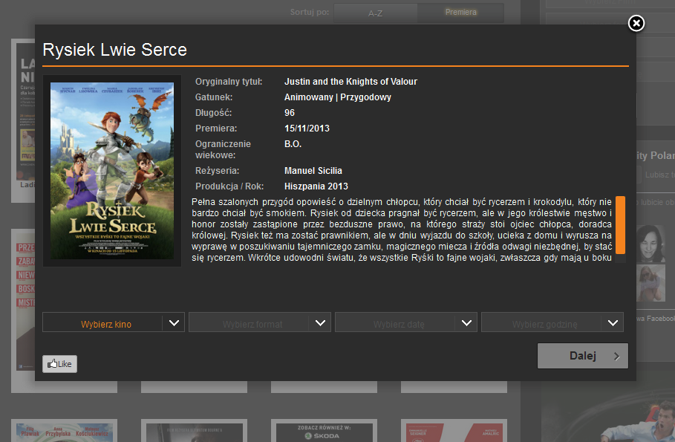

Figure 3

On the screen with description of movie (figure 3) user has a simple form that they can use when want to buy a ticket. There is observed next **bad practice**. The user isn’t informed that he can use this form to buy tickets.

In this form user firstly can choose the cinema (this website is only about one cinema company so it doesn’t have all cinemas in some area). After, the user can choose what type of movie he wants to see (if any types are available, e.g. 2D, 3D, dubbing, subtitles). After he chooses date and hour.

When the user fills out the form, he can decide if he want to only book or buy tickets. After choose one of this options user needs to accept conditions and rules of the cinema. One of the last steps is choose how many (and what type: for adults, children, students) tickets user want to buys/books and numbers of the seats (figure 5).

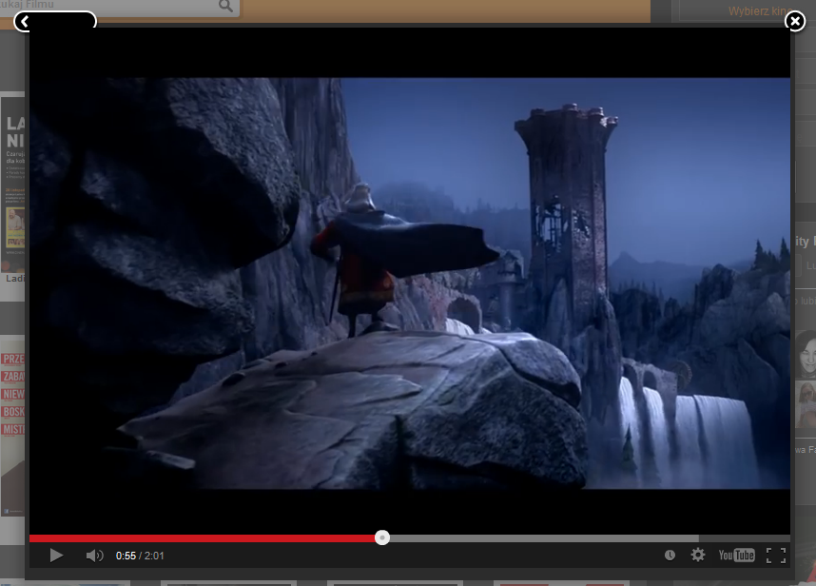

Figure 4

When the user finishes all steps he need only fill the form about his personal data (name, surname, email address and phone number).

The whole process is very linear and user shouldn’t have any problems with forms and this process.

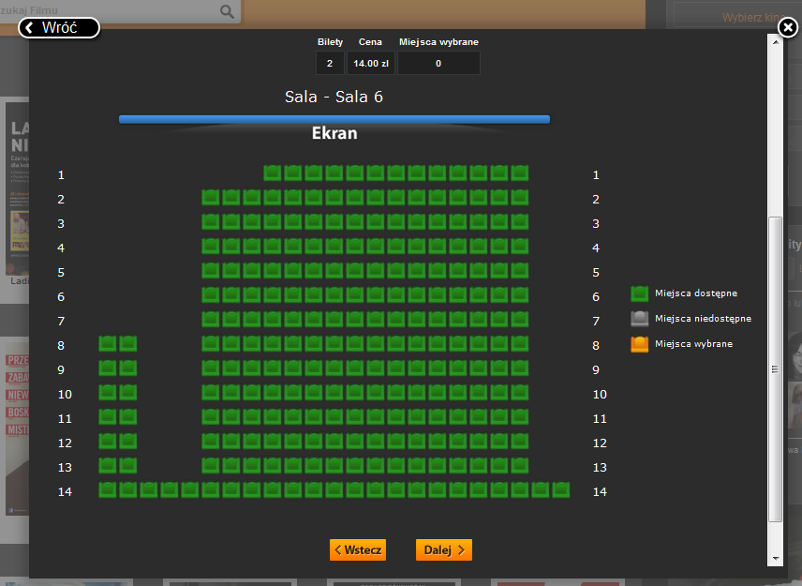

Figure 5

**Cinema-City Conclusion**

**Good practices:**

* The process of buying/booking the ticket is very linear. When the user starts this process he shouldn’t lost.
* On the homepage all the movies are shown as pictures of the posters with labels. This way is very clear and easy to read.
* The search tool gives some search tips.
* User can choose what type of films he is looking for (3D, 2D, dubbing etc.) using tabs.
* The screen with description of movie is shown in new window which can be easy closed by clicking the space outside this new window.
* User has a choice: book or buy the tickets.
* The map of the cinema room is shown during booking/buying process. User can very easy choose seats.

**Bad practices:**

* User don’t get full information to know how to make reservation of the tickets, he needs to know that form under movie description is used to make this reservation.
* Some buttons (e.g. “return” button during showing movie trailer) aren’t exposed enough. User can have a problem with find it.

# [www.helios.pl](http://www.helios.pl)

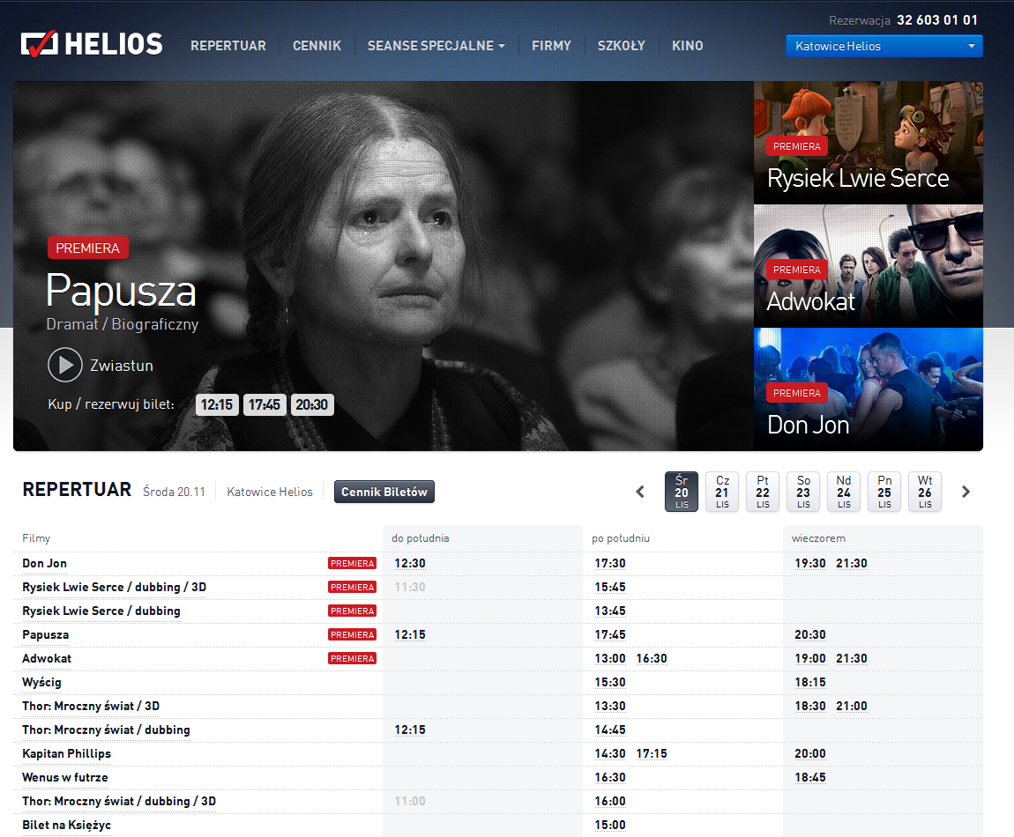

Figure 6

This is next website of a Polish cinema company. The homepage (figure 6) shows repertoire of one cinema (in this case cinema in Katowice City – this option was remembered after last session). The cinema can be changed in every moment in the right top corner.

The first part of the homepage is advertisements of the newest movies. Users can click on one of these advertisements and read a description of the movie. Below these advertisements, the user can find a full list of movies played in this cinema. On the top part of this section the user can choose the date and also can open the site when can check prices of the movies (“ceny biletów”).

When the user decides which cinema and date he can choose one of the movies from the list. The user has two options now. He can click on the name of the movie or on the selected date. If he clicks on the date he will be situated on the book/buy screen. If the user chooses name of the movie the website with description of movie will be shown (figure 7).

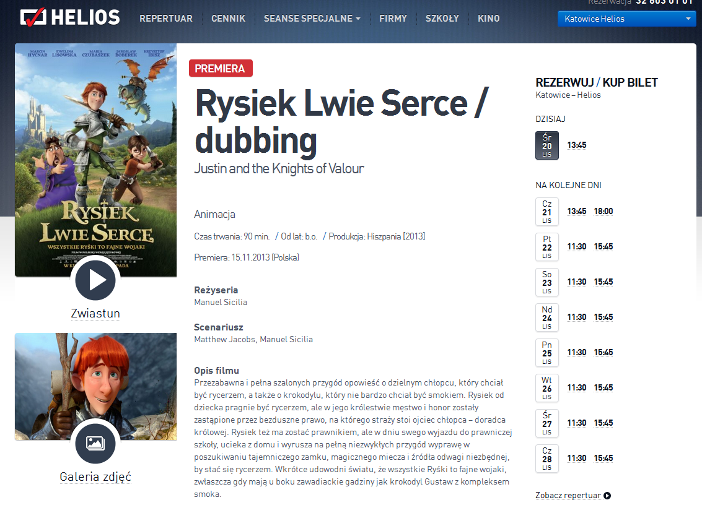

Figure 7

From this site (figure 7) the user can open a trailer or photo gallery of the selected movie. Both are opened in new windows, easy to close and return to description of movie. On the right side, the user can choose the day and time of the movie. When he does it, a new window is shown (figure 8). On this window the user can choose if he want to book or buy tickets on this showing. After making a choice the screen with cinema room is shown (figure 9). The user can choose how many and which places want to book/buy.

When the user chooses the location he is asked to accept the choice. The last step is to fill the form with personal data (name, surname, email address and phone number).

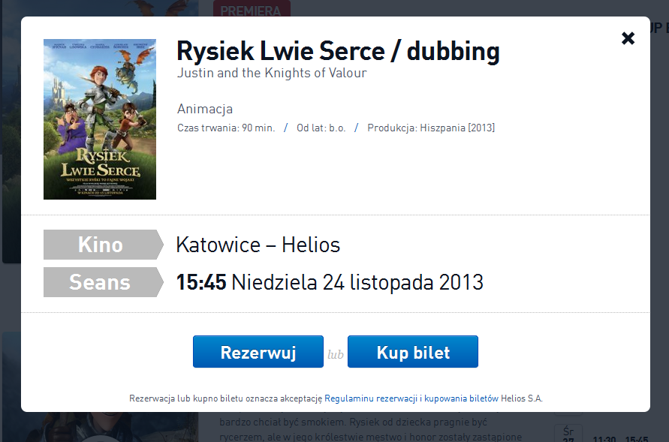

Figure 8

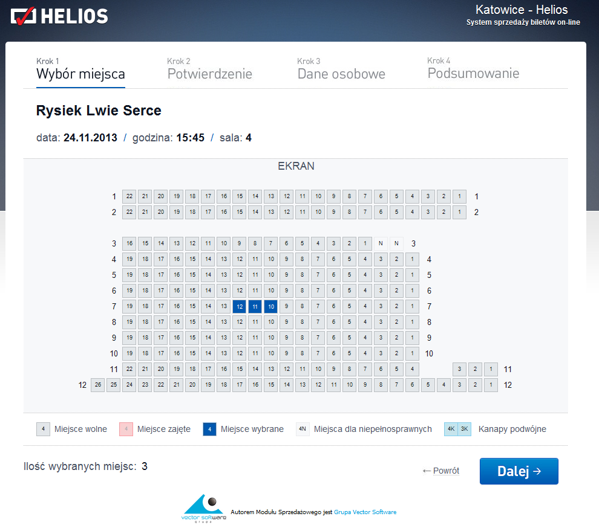

Figure 9

**Helios Conclusion**

**Good practices:**

* The user can watch trailer of the movie and pictures gallery.
* The map of cinema room is available – it makes easier to choose the seats.
* The process is very linear. Difficult to lost.
* User has a choice: book or buy the tickets.

**Bad practices:**

* User isn’t fully informed how to make a reservation. He needs to know that he should to click on the name of movie or time of show.

1. Low Level Prototypes

Prototype for Our Home page

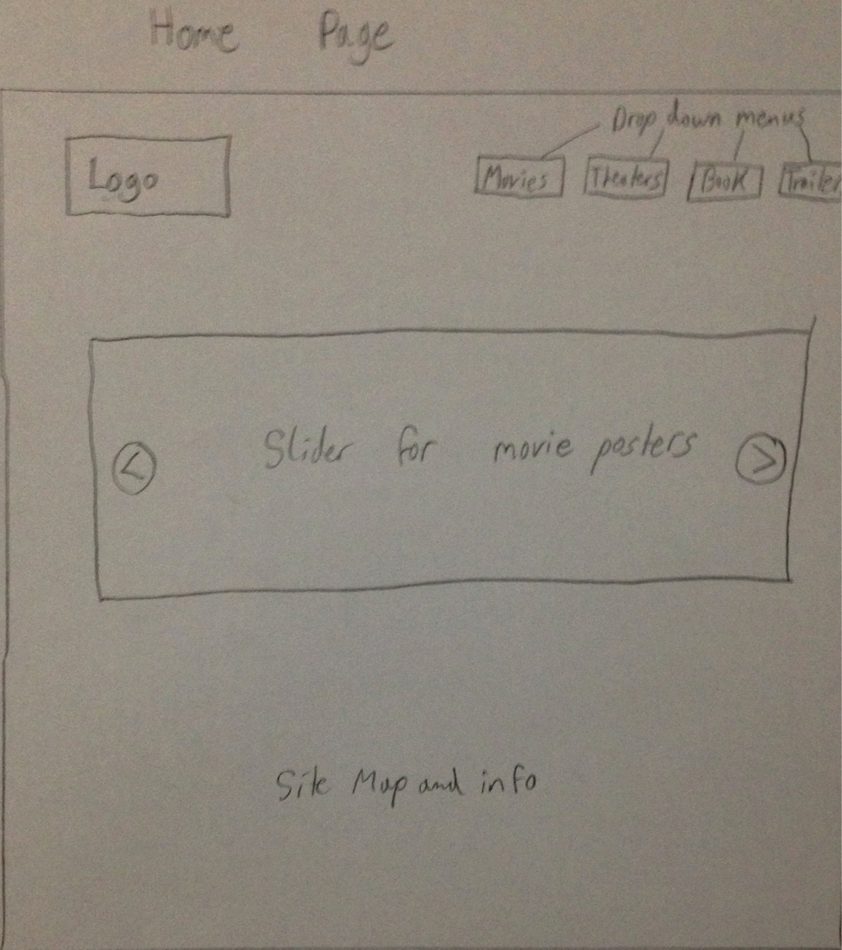

Prototype for The Page for One Theater

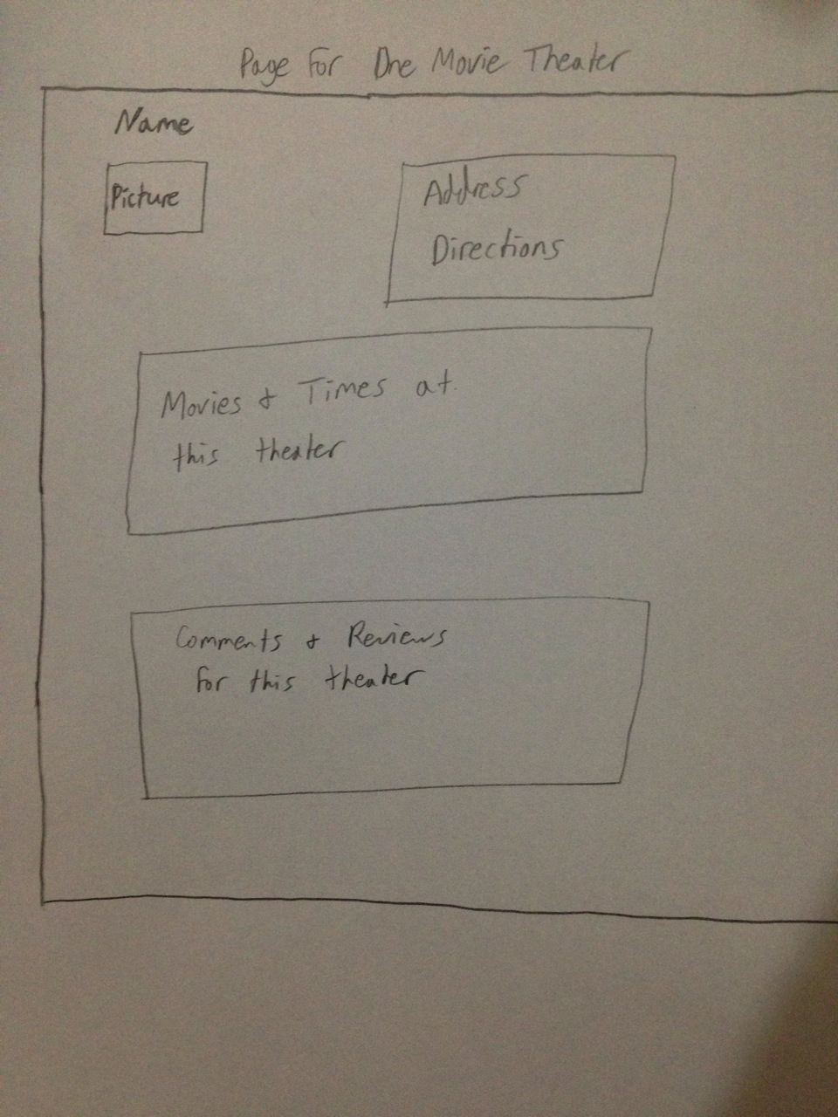

Prototype for the Page For a Movie

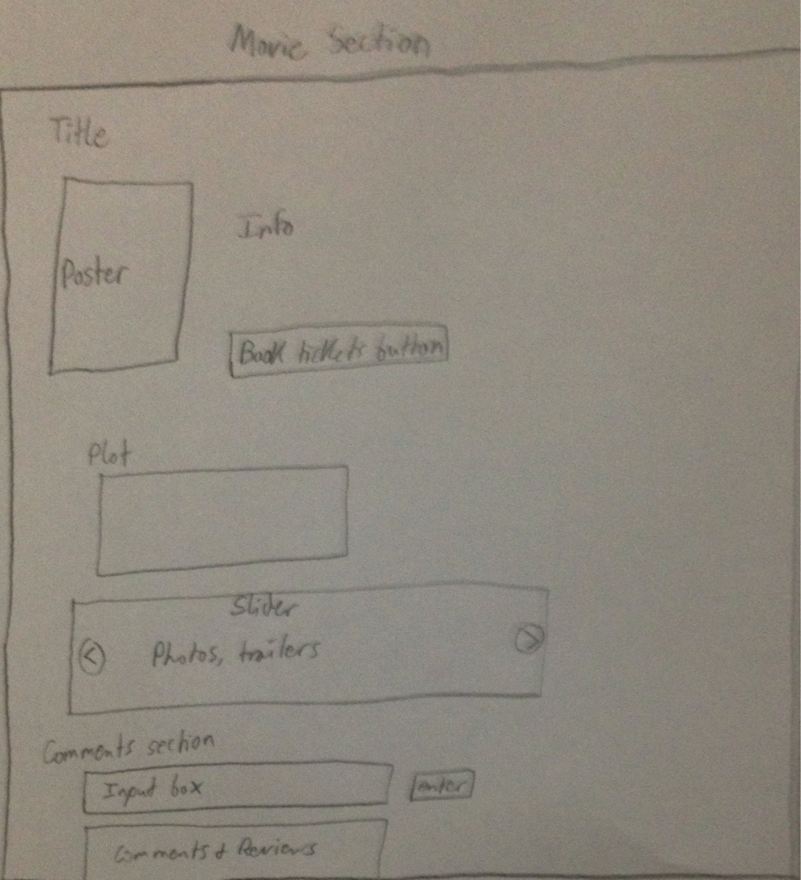

5 Web Design Patterns Used

The process of creating the website was strongly connected with good practices of design. First of all the authors check other, similar site and found there good and bad things. The next step was to use patterns and heuristics method to make the website better.

The most important rule, which was adapted to website was to keep everything as easy to use as it is possible. To obtain this goal the heuristic was used.

Authors of this document decided to use Nielsen’s heuristics to check if the website is as easy to understand as possible. Some points of heuristics were chosen: “Match between system and the real world”, “user control and freedom” and “aesthetic and minimalist design”. These points were considered as the most important in this case.

At the end of the design process the inspection method according Nielsen’s heuristic method was used again to check if website is design in proper way. During inspection some elements of the website was improved, e.g.: the colors of the text were changed and the order of the menu was fixed to the easier to understand.

During creating the website the language of web patterns was used. First of all the point B was considered: “creating a navigation framework”. The first thing created was multiple way to navigate. User can choose the movie from many ways on the website (e.g. from homepage or from menu – figure 10). Also, authors of this project designed good organization of content. It is connected with point B2 – browsable content.

The website has the strict hierarchy. This way of design the website allows users to feel comfortable. The website is easy to navigate in this case. Also, authors remember that the structure of hierarchy shouldn’t be too big.

Inside the website the D7 web pattern was used. The inverted-pyramid writing style is used to show the user the most important information and allow to him find the rest part of information. In this way user isn’t lost with too many information in the same time.

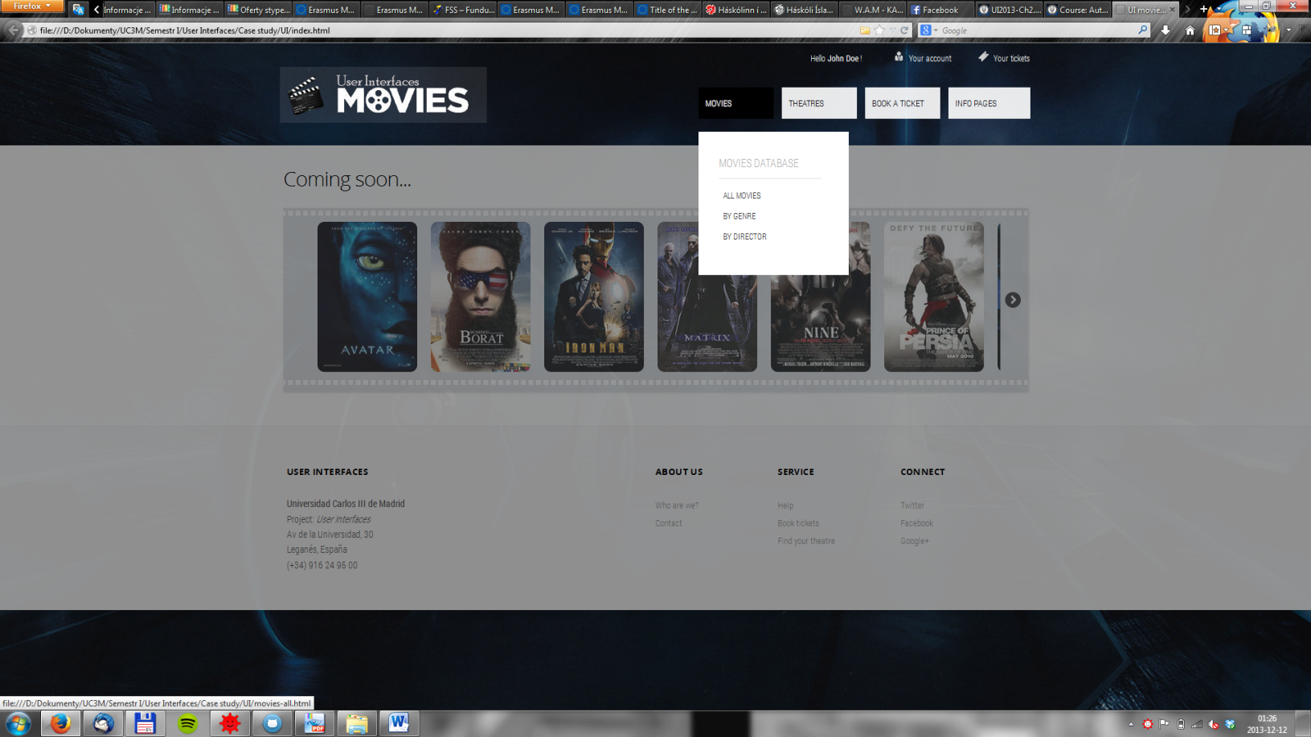

Figure 10. Possibility to choose the movie in many ways.

Below we have a more complete listing of web design patterns used in our interface:

* B Patterns
  + Multiple ways to navigate to buy a ticket (B1)
  + Multiple ways to find a movie time
  + Hierarchical and task-based organization (B3 and B4)
  + Category pages (genre, director, etc) (B8)
* C Patterns
  + Homepage portal (C1)
  + Up-front value proposition (C2)
* D Patterns
  + Consistent page templates (D1)
  + Dedicated, clear content modules (D2)
  + Personalized content (D4)
    - Ability to create your own profile
  + Message boards (D5)
    - Comments and reviews sections
  + Inverted-pyramid style (D7)
  + Style sheets (D11)
* E Patterns
  + Site Branding (E1)
    - Logo in top left corner
    - Consistent style
  + E-mail subscriptions (E2)
    - Would be put into action by using the user profile in a real-life scenario
  + About us page (E5)
* H Patterns
  + Sign-in/New Account (H2)
  + Guest Account (H3)
    - Able to purchase without creating an account
  + Account Management (H4)
    - Would be put into action by clicking on the “your account” link in the header of each page
  + Clear, concise forms (H10)
  + Progress Bar (H13)
    - On checkout pages
* K Patterns
  + Unified browsing hierarchy (K1)
  + High-visibility buttons (K5)
  + Location bread crumbs (K6)
    - Location is given at the top of each page
  + Embedded and obvious links (K7 and K10)
  + Familiar, easy language (K11)
  + Prevent errors, give meaningful feedback (K12 and K13)
    - On the form to buy tickets

6 Documentation and Explanation of Source Code

One main thing to note as one views our site is that we have only designed the interface of the website. This means that, although all pages are connected, no data from the user is actually being saved. By having the interface in place, someone should now theoretically be able to come in and make it a functioning site. This, however, was beyond the scope of this course.

We have created only one “movie.html” page and one “theater.html” in hope to demonstrate how a specific theater or movie will be displayed.

The file structure for the website is as follows (**bold** = a folder):

* **Report**
  + Report.pdf
* **Src**
  + book-1-what-where-when.html
  + book-2-choose-a-sit.html
  + book-3-checkout.html
  + book-4-ticket.html
  + index.html
  + info-pages.html
  + movie.html
  + movies-all.html
  + movie-by-director.html
  + movies-by-genre.html
  + theater.html
  + theaters-all.html
  + theaters-map.html
  + **images**
    - Filled with all images for the website
  + **css**
    - buttons.css
    - elastislide.css
    - menu.css
    - template.css
  + **script**
    - chooseSeats.js
    - form-check.js
    - jquery.elastislide.js
    - jquerypp.custom.js
    - map.js
    - menu.js
    - modernizr-min.js
    - modernizr.custom.17475.js
    - responsive-menu.js